20.51: a) The cylinder described contains a mass of air 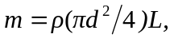 and so the total kinetic energy is 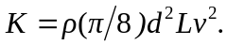 This mass of air will pass by the turbine in a time 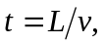 and so the maximum power is
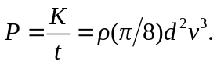
Numerically, the product 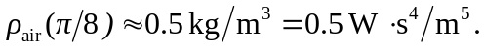
b) 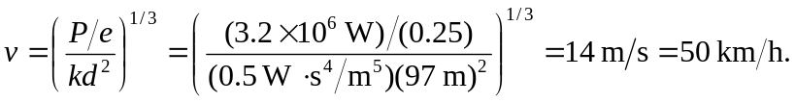
c) Wind speeds tend to be higher in mountain passes.

